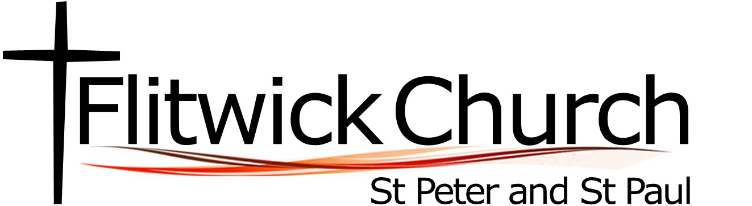

MISSION ACTION PLANNING - July 2023

1st Priority – Community Connection Transforming Communities / Making New Disciples

Planning ways to intentionally engage and effectively communicate
with the local community to make our presence known and shine Christ’s light.

1) Three community engagement events throughout the year (Christmas, Easter, Summer)
Completion aim: Sept 2024 and then ongoing each year
Lead: Leading Your Church into Growth (LYCiG) focus group / Event Team

2) Engaging with our local schools by offering an Easter Journey to all lower schools – either to be held in the church or taken into schools.
Completion aim: Easter 2024
Lead: Sophie Tucker, Pioneer Enabler.

3) Develop a communication strategy for engaging with our community – looking at how can we communicate more effectively, who we are and what we do? Reviewing our social media presence, mailchimp email system, parish magazine, notice sheets
Completion aim: Summer term 2024
Lead: Leading Your Church into Growth (LYCiG) focus group

2nd Priority – Rooted in Faith Going Deeper into God
Developing the Spiritual Life of the Church

We have a desire to grow as a praying community and recognise the need to focus our attention on the praying heart of the church. We hope to listen well to God and to learn His will for us as a church and community.

1) Creating a prayer space in the church for those who visit when the church is open and also to allow for some creative prayer opportunities. This also allows for prayer ministry to be a focal point for our church community.
Completion aim: Easter 2024
Lead: Sam Davis

2) Organise and gather a church wide walking pilgrimage to St Albans Cathedral.
Completion aim: Easter Monday 2024
Lead: Revd Andy

3) Bringing together a team to develop and encourage prayer ministry within the church.
Completion aim: Summer 2024
Lead: Revd Claire

3rd Priority – Growth (Young People) Making New Disciples / Going Deeper into God

With no current provision for the young people in our church or on the fringe of our church community, we aim to intentionally focus on creating opportunities for
spiritual and personal growth for our young people.

Fostering an environment where our young people are known to be valued and appreciated.

1) Setting up and running an activity (ice skating & pizza night) that encourages engagement with our current group of young people and listening to their needs and hopes for youthwork at our church.
Completion aim: Sept 2023
Lead: Revd Claire & Revd Andy

2) Develop and grow a team to work with our young people.
Completion aim: Jan 204
Lead: Revd Andy & Revd Claire

3) Start a regular group/session to encourage and engage young people in their faith.
Completion aim: Jan 2024
Lead: Youth Team

